GUARDERIA - NURSERY - ESCUELA INFANTIL – LLAR D’INFANTS – KINDERGARDEN

CHIQUI LA VILA

KINDERGARTEN (0-3 year)

For 4 months-old babies to 3 year-old

Staff is trained to maintain a warm and friendly approach, looking for children to respond positively to their surroundings and to benefit from being treated as an individual.
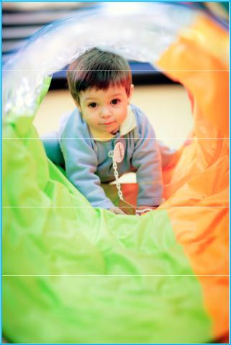
The baby room is cosy and has low-level support equipment to allow babies to pull themselves up as they learn to walk. The toddler room is an ideal environment to support learning and resources and activities are set out to allow the children space to move freely.

The equipment, smart boards and sensory development children’s development and transition onto ‘big school’ rooms.

toys, are a huge advantage for in the nursery and pre-school

 |  |  |  |  | Schedule
 |  | 7h30 |  |  | Arrivals
 |  | 9h30 |  |  | Breakfast
 |  | 10h |  |  | Activities, playtime
 |  | 11h30/12h |  |  | Lunch
 |  | 13h-… |  |  | Siesta time
 |  | 15h |  |  | Activities, playtime
 |  | 15h30/16h |  |  | snack
 |  | … -19h |  |  | Playtime
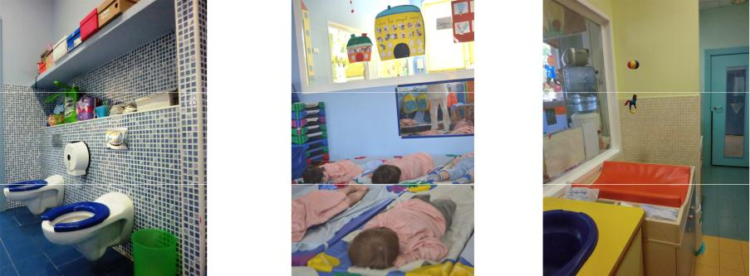
Chiqui La Vila

www.escuelachiquitin.com | c/ Salvador Espriu nº71, local
mail: lavila@chiquitin.es | Salida playa del C.Comercial Centre La Vila
tel. 93 221 95 79 | 08005 Barcelona –Vila Olímpica

GUARDERIA - NURSERY - ESCUELA INFANTIL – LLAR D’INFANTS – KINDERGARDEN

CHIQUI LA VILA

CAMPUS (3 to 6 years-old)

“Casal” Days.

Children really enjoy the day participating in very varied activities: arts and craft, games and songs, puppets, excursions, beach, etc. according to the age of the group and the season.

Opening hours: 7h30-19h (August: 8h-18h).

* For students enrolled in the nursery, the “Casal” is included in the monthly

fee of the school
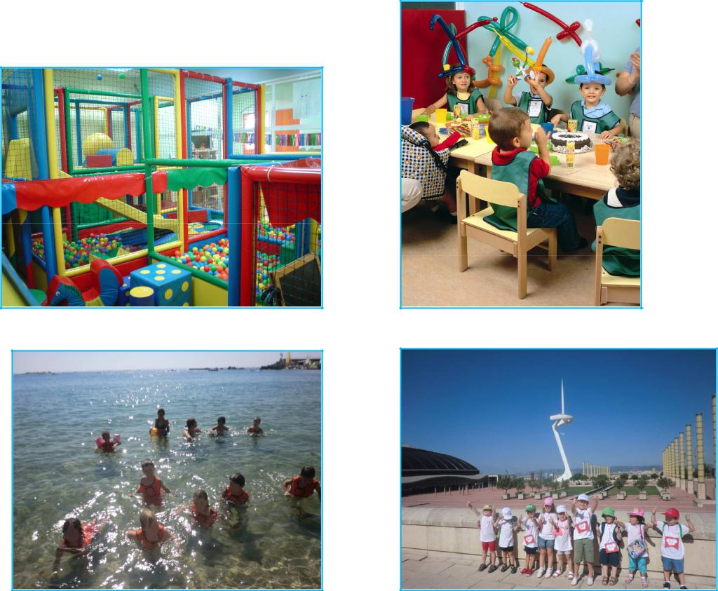

Chiqui La Vila

www.escuelachiquitin.com | c/ Salvador Espriu nº71, local
mail: lavila@chiquitin.es | Salida playa del C.Comercial Centre La Vila
tel. 93 221 95 79 | 08005 Barcelona –Vila Olímpica

GUARDERIA - NURSERY - ESCUELA INFANTIL – LLAR D’INFANTS – KINDERGARDEN

CHIQUI LA VILA

SPECIAL OFFER FOR

PRBB STAFF

10% discount

Full day (breakfast, lunch & snack - home made food included): 9h-17h = 35€-10%= 31,50€

Spare hours: 5€/hour

Spare lunch: 9€

Breakfast or snack: 2,5€

Contact for further information:

Contact Chiquitin : Ivette (tel. 93 221 9579 or email: lavila@chiquitin.es)

SUBJECT TO AVAILABILITY OF POSTS IN THE KINDERGARTEN

Other services: evening or weekend babysitter

In order to benefit from this condition you have to request a work certificate in your institution.
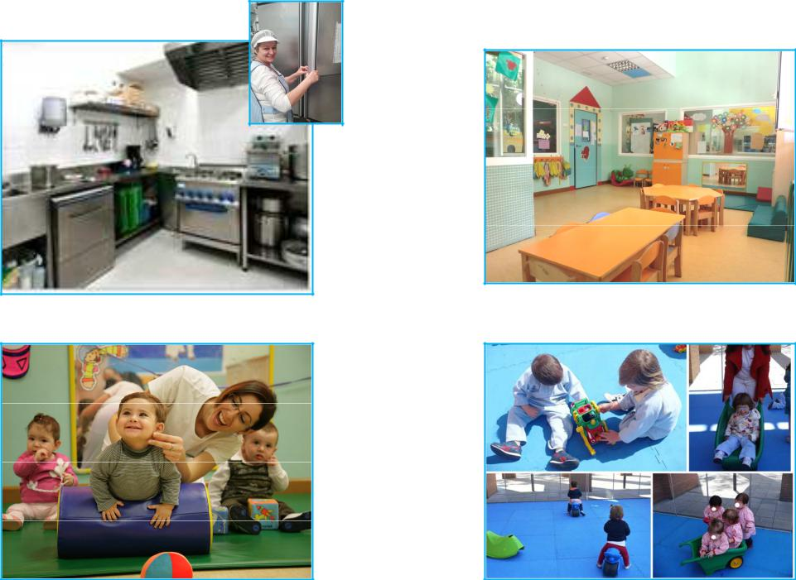

Chiqui La Vila

www.escuelachiquitin.com | c/ Salvador Espriu nº71, local
mail: lavila@chiquitin.es | Salida playa del C.Comercial Centre La Vila
tel. 93 221 95 79 | 08005 Barcelona –Vila Olímpica

GUARDERIA - NURSERY - ESCUELA INFANTIL – LLAR D’INFANTS – KINDERGARDEN

CHIQUI LA VILA

Where is Chiqui La Vila
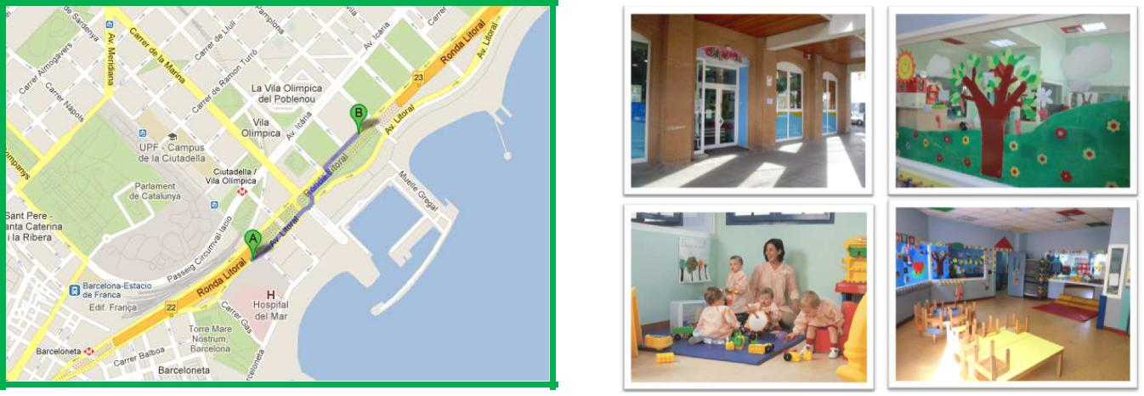

A : PRBB

B : Chiqui La Vila

Contact for further information: Contact PRBB: Elvira López (tel. 93 316 00 11)

Contact Chiqui: Ivette (tel. 93 221 9579)

*Offer for each of the seven independent research organisations located in the PRBB:

- IMIM (Institut de Recerca de l’Hospital del Mar),
- Dept. de Ciències Experimentals i de la Salut (CEXS-UPF),
- Centre de Regulació Genòmica (CRG),
- Centre de Medicina Regenerativa de Barcelona (CMRB),
- Centre de Recerca en Epidemiologia Ambiental (CREAL),
- Institut de Biologia Evolutiva (IBE: CSIC-UPF),
- Fundació Pasqual Maragall (FPM) 2009,
- Consorci PRBB,

**Chiquitin La Vila has all the educational, sanitarian and environmental licenses of the Generalitat de Catalunya.

**Chiquitin La Vila is subsidized by the Generalitat de Catalunya since 2009.

Chiqui La Vila

www.escuelachiquitin.com | c/ Salvador Espriu nº71, local
mail: lavila@chiquitin.es | Salida playa del C.Comercial Centre La Vila
tel. 93 221 95 79 | 08005 Barcelona –Vila Olímpica

GUARDERIA - NURSERY - ESCUELA INFANTIL – LLAR D’INFANTS – KINDERGARDEN

CHIQUI LA VILA

Registration Form

Photo

NAME:
Last name:
Birthday:
Address:
Cellphone:
Full name mother:
Full name father:
Email:
Allergies/ food intolerance:
(Justified by a medical certificate of the pediatrician)

Comments:

Schedule:
Date:

Payment will be made on site the same day.

Required documentation:
- Copy of the vaccines certificates
- Birth certificate
- Passport-size photo
- Copy pf the parents/guardians and people authorized to pick them up or ID card
- International health insurance

We recommend bringing a bag with everything that the baby/child might need: diapers, baby wipes, feeding bottle or small bottles, spare clothes, pacifier, cream etc.
Everything has to have the name of the child in order to avoid any loss.

I ……………………………..…with ID …………………….. hereby authorize the Chiquitin La Villa Centre to:
- Take pictures with my child for internal use only
- Administer an antipyretic to my child if the fever should exceed 38º and if necessary take him/her to a hospital or Primary Health Care Center

I hereby acknowledge the above today (date): ………………..(day)………………………(month)……(year)

The Centre reserves the right to modify or cancel the activity subject on the minimum number of children.

Chiqui La Vila

www.escuelachiquitin.com | c/ Salvador Espriu nº71, local
mail: lavila@chiquitin.es | Salida playa del C.Comercial Centre La Vila
tel. 93 221 95 79 | 08005 Barcelona –Vila Olímpica

